14-3_SQL_Trushkova_Managing_Constraints

To deactivate an integrity constraint-DISABLE CONSTRAINT

Disables dependent integrity constraints- CASCADE clause

To add, modify, or drop columns from a table- ALTER TABLE

To activate an integrity constraint currently disabled- ENABLE CONSTRAINT

Removes a constraint from a table- DROP CONSTRAINT

Allows user to delete a column from a table-DROP COLUMN

Defines the actions the database server takes when a user attempts to delete or update a key to which existing foreign keys point- CASCADE CONSTRAINTS

1.What are four functions that an ALTER statement can perform on constraints?

1. ADD
2. DROP
3. ENABLE
4. DISABLE

2. Since the tables are copies of the original tables, the integrity rules are not passed onto the new tables; only the column datatype definitions remain. You will need to add a PRIMARY KEY constraint to the copy_d_clients table. Name the primary key copy_d_clients_pk . What is the syntax you used to create the PRIMARY KEY constraint to the copy_d_clients.table?

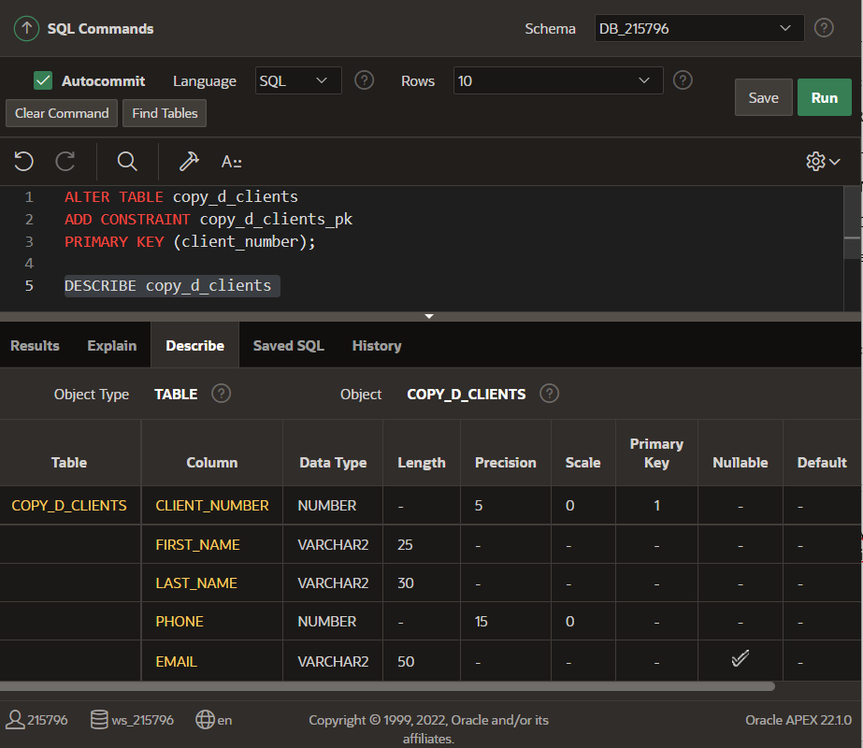

3. Create a FOREIGN KEY constraint in the copy_d_events table. Name the foreign key copy_d_events_fk. This key references the copy_d_clients table client_number column. What is the syntax you used to create the FOREIGN KEY constraint in the copy_d_events table?

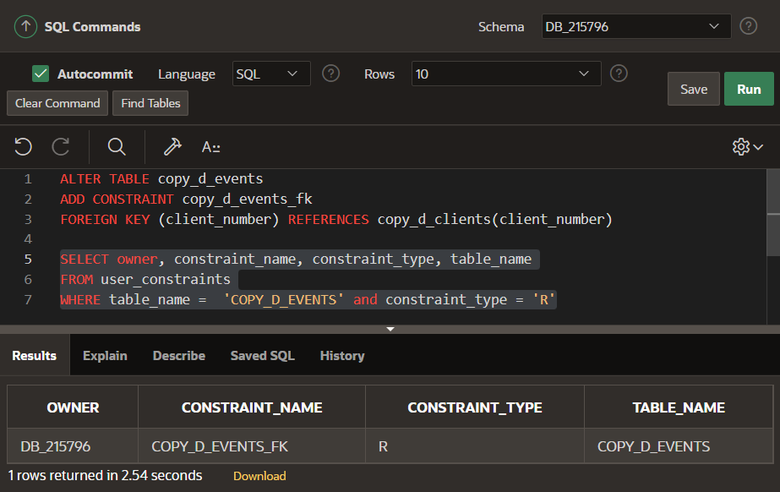

4. Use a SELECT statement to verify the constraint names for each of the tables. Note that the tablenames must be capitalized.

5. Drop the PRIMARY KEY constraint on the copy_d_clients table. Explain your results.

Нельзя удалить это ограничение, так как на него ссылается другое ограничение (внешний ключ)

6. Add the following event to the copy_d_events table. Explain your results.

|  |  |  |  |  |  |  |  |  |
| --- | --- | --- | --- | --- | --- | --- | --- | --- |
| ID | NAME | EVENT_DATE | DESCRIPTION | COST | VENUE_ID | PACKAGE_CODE | THEME_CODE | CLIENT_NUMBER |
| 140 | Cline Bas Mitzvah | 15-Jul-2004 | Church and Private Home formal | 4500 | 105 | 87 | 77 | 7125 |

Ошибка из-за того, что нет такого первичного ключа в таблице, на которую ссылаемся

7. Create an ALTER TABLE query to disable the primary key in the copy_d_clients table. Then add the values from #5 to the copy_d_events table. Explain your results.

8. Repeat question 5: Insert the new values in the copy_d_events table. Explain your results.

9. Enable the primary-key constraint in the copy_d_clients table. Explain your results.

10. If you wanted to enable the foreign-key column and reestablish the referential integrity between these two tables, what must be done?

Внешний ключ должен ссылаться на СУЩЕСТВУЮЩИЙ первичный ключ в другой таблице

11. Why might you want to disable and then re-enable a constraint?

Когда уверены в правильности введенных нами данных и не хотим тратить время на прокерку

12. Query the data dictionary for some of the constraints that you have created. How does the data dictionary identify each constraint type?

Code Description Acts On Level

------------------------------------------------------------

C Check on a table Column

O Read Only on a view Object

P Primary Key Object

R Referential (Foreign Key) Column

U Unique Key Column

V Check Option on a view Object